**PWC Module Description Document**

**1.Introduction**

The AP80 series chips provide a PWC module that can precisely calculate the frequency of input pulses of 2 MHz or below and the duty cycle of input pulses of 20 kHz or below, with a duty cycle measurement range of 1% to 99%. The PWC module uses a 12MHz clock and can measure different modes: the number of clock cycles between rising edges, the number of clock cycles from a rising edge to a falling edge, the number of clock cycles from a falling edge to a rising edge, the number of clock cycles between falling edges, and the number of clock cycles between the current trigger edge and the next trigger edge. Upon completion of the measurement, if the PWC interrupt is enabled, the module generates an interrupt flag and enters the interrupt handling function. In addition to obtaining data via interrupt, the flag can also be queried to read the measurement data. After reading the data, the flag must be cleared by software.

**2.Main Performance**

* Supports five capture modes: rising edge to rising edge trigger, rising edge to falling edge trigger, falling edge to rising edge trigger, falling edge to falling edge trigger, and edge to edge trigger.
* Supports two data acquisition methods: interrupt and query.
* It can precisely measure frequencies up to 2MHz.
* It can precisely measure the duty cycle up to 20kHz.
* Duty cycle measurement range: 1% to 99%;

**3.Configuration Process**

1.Enable PWC functionality

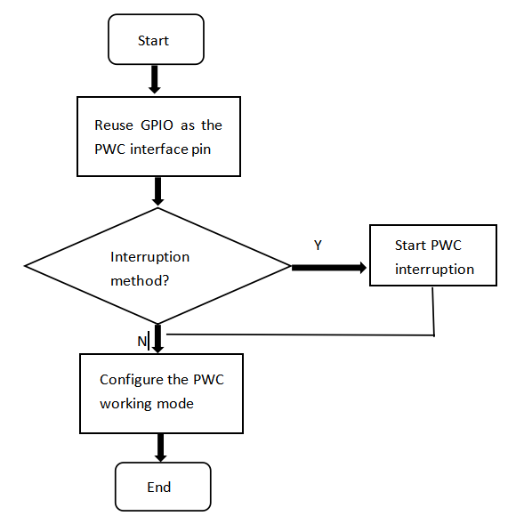

Figure 1: PWC usage configuration

2.Exit the PWC function

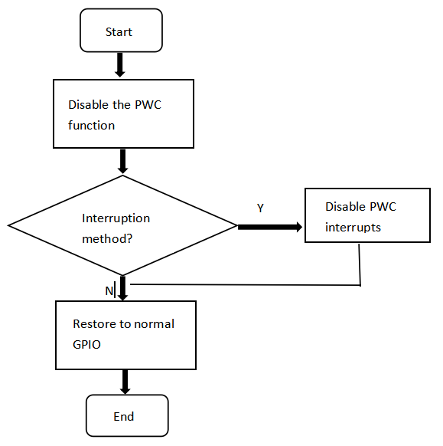

Figure 2 Disable PWC configuration